NATURAL PRODUCTS FIELD MANUAL

Newly revised, updated, expanded Fourth Edition

The single best investment you can make to profitably grow your business

- Complete, comprehensive, 4 volume guide on “how to go to market” in the natural, specialty, grocery and club channels with overviews of food service, Canada and the UK markets.
- 44 chapters, 760 pages of hard won knowledge and experience that you can apply to your business
- Includes CD with directory of top retailers, natural buyers in mainstream supermarkets, distributors, brokers, new item forms, budget models, and industry resources
- Practical, proven, best practices shared and illustrated
- Rich, insightful guest essays, editorials and color commentary by 66 notable buyers, brokers and CEO’s
- Over $15,000 worth of coupons on services you can use-- including free half-day consulting
- Pays for itself many times over

Name: _________________________________________
Company Name: ________________________________
Mailing Address: ________________________________
City, State, Zip: _________________________________
Phone: __________________Fax: _________________
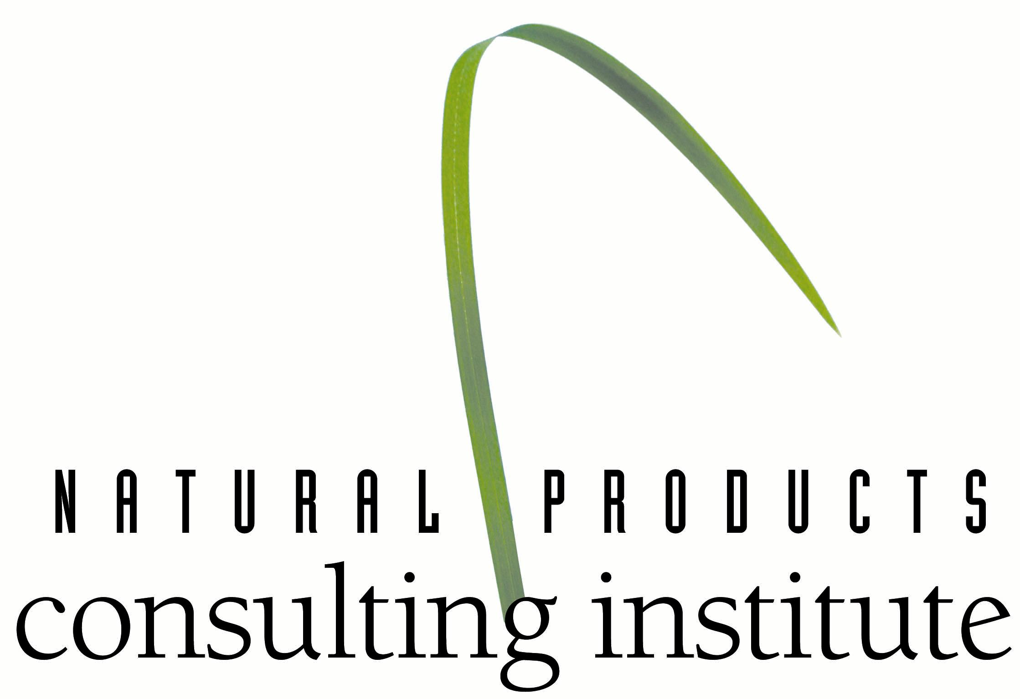
Email: _________________ Website: ______________

I wish to invest in profitably growing my business.
Please send me the Fourth Edition of the Natural Products Field Manual
Price $2,999.00 Standard S&H $15.00,
International shipping and insurance $50.00
MA customers please pay 5% state sales tax

Net Price Billed to Credit Card $_______________________

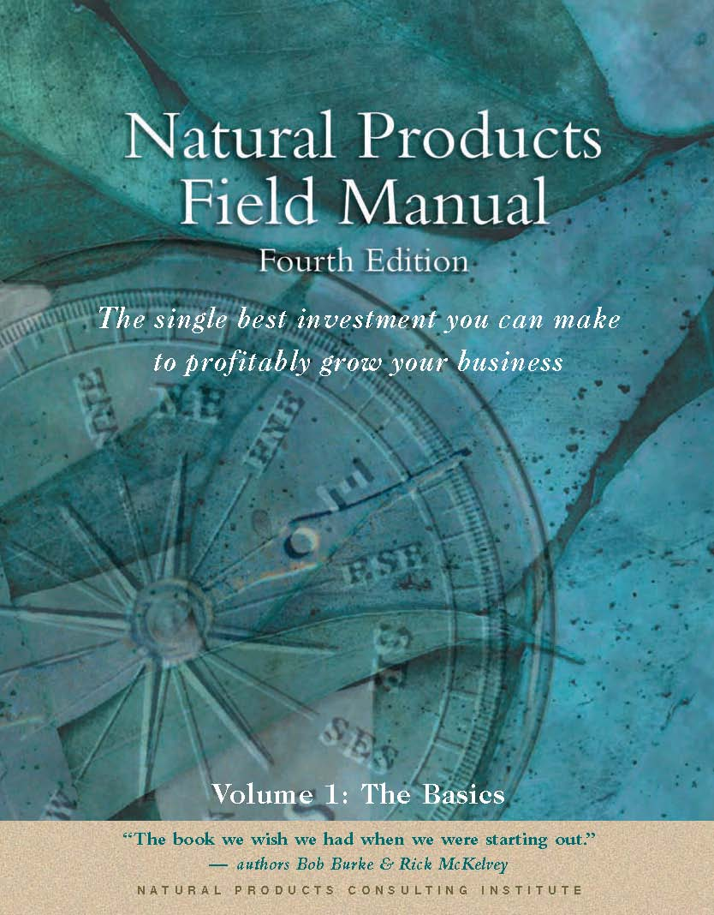
Payment:
Check enclosed____ Make checks payable to
“Natural Products Consulting Institute, LLC”
Circle one: Master Card, Visa, American Express

Credit Card Number: _________________________________________
Name as appears on card:______________________________________
Expiration Date:_____________________________________________
Signature: __________________________________________________
Referred by: ________________________________________________

Return to:
Bob Burke
Natural Products Consulting Institute, LLC
8 Cobblestone Lane, Andover, MA 01810
Tel: 978-975-9902 Fax: 978-975-4502
BBurke@NPCInstitute.com www.NPCInstitute.com www.NaturalConsulting.com

Table of Contents
Volume I: The Basics
Margins and Pricing Budgeting and Planning Industry Resources Supply Chain Savvy
New Products Running Successful Off-sites Managing Co-packers Sales Force Automation
Building a Sales Organization Product Quality Strategic Planning Private Label

All about Brokers Ingredient Standards Financing Nutrition and Personal Care

Summary “If we knew then what we know now”

Volume 2: Trade Marketing
Natural & Specialty Distributors Trade Promotion Category Management Food Service Overview
Retail Overview: Natural Foods Trade Funds Management Trade Show Investment Using Market Research
Mainstream Supermarkets Trade Advertising Exporting Basics Overall Channel Approach
“Covering your Butt”

Volume 3: Consumer Marketing
Branding Consumer Promotion Consumer Advertising Packaging
Maximize your database Public Relations programs Special Events Marketing

Volume 4: Trends and Updates
Industry overview Natural, Grocery, Mass and Club updates Canadian Opportunity
Natural and Specialty Distributor updates UK Opportunity Defining the natural/organic consumer

About the Enclosed CD-ROM
- Natural retailer database
- Summary of Supermarkets with natural sets – buyer information and main supplier listed
- Directory of Natural/ Specialty Distributors
- Directory of Brokers – with sample broker contracts
- Sample budgets and P&L models
- Basic breakeven calculations
- Supermarket News Top 75 Supermarkets
- Key Distributor and Retailer Programs
- New Account forms
- Key Customer logos
- PR Database
- Trade Spending Model with form and Trade Spending log
- 4th Edition Updates

Over $15,000 in Coupons
SPINS Mambo Sprouts New Hope Natural Media Castle Group PR
McGovern Communications UNFI RML Naturals PeoplesWorth
Ethos Marketing Kiwi Magazine Nutrition Business Journal Turnlink Wholesome Sweeteners Volkman Group Global Organics and more!

Also: Free Half-Day Consulting Session by Authors $1,000 value!

“I can't think of a company in the industry that wouldn't benefit tremendously from the Natural Products Field Manual ."
--- Dan Atwood, Senior Vice President, United Natural Foods, Inc.
The single greatest cost that any entrepreneur incurs is the “Learning Curve”. It can make you, break you, or sentence you to a slow, tortuous death. Bob’s and Rick’s Natural Products Field Manual will absolutely cut this cost in half, if not eliminate it altogether. I only wish I’d had a copy 19, or even 2, years ago."
"If the Natural Products Field Manual doesn’t save your firm tens of thousands of dollars, or garner you many more thousands in revenues, then save yourself the trouble and close your business. The problem lies with you, not the authors. This compendium is an invaluable gem." -- Gary Hirshberg, President/CEO Stonyfield Farm Yogurt

